Creating Users and Roles

1. Login to your supplier account at supplier.ariba.com
2. Click initials in top right-hand corner of homepage and click settings:

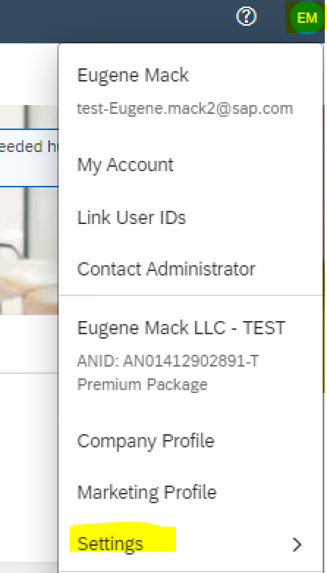

1. Select “Users”:

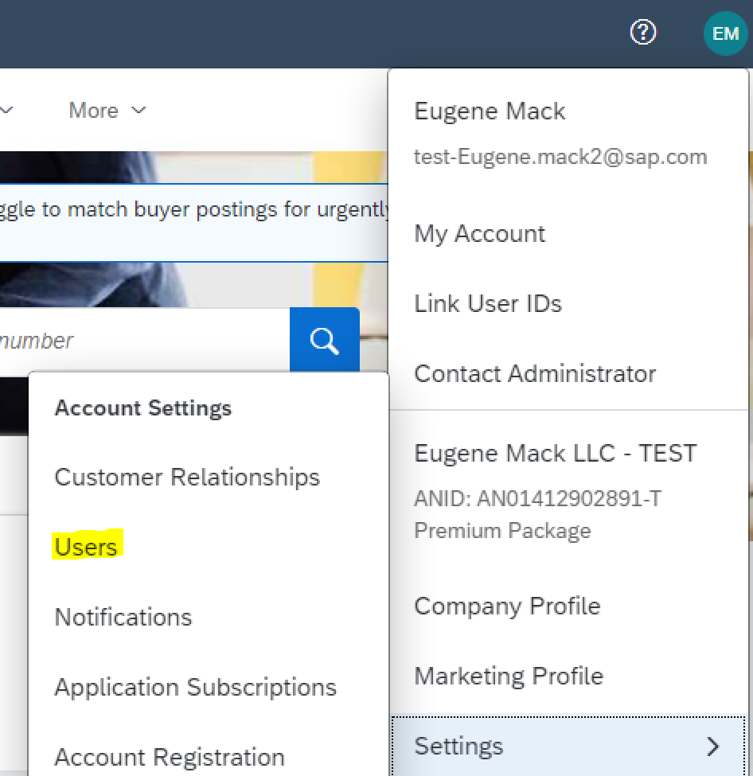

1. Click “Manage Users” subtab:

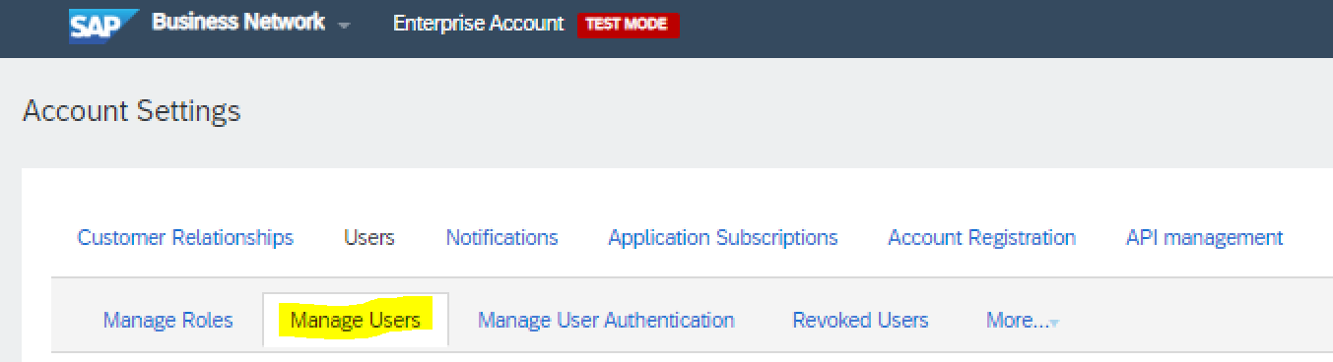

1. Find the user record you are making the edit to, select “Actions” dropdown menu and select “edit”:

