Creating Users and Roles

1. Login to your supplier account at supplier.ariba.com
2. Click initials in top right hand corner of homepage and click settings:

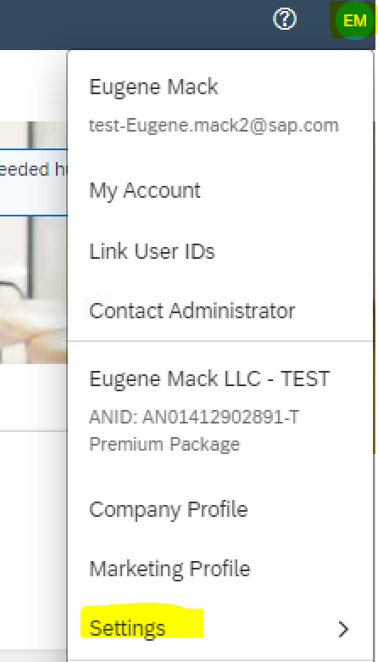

1. Select “Users”:

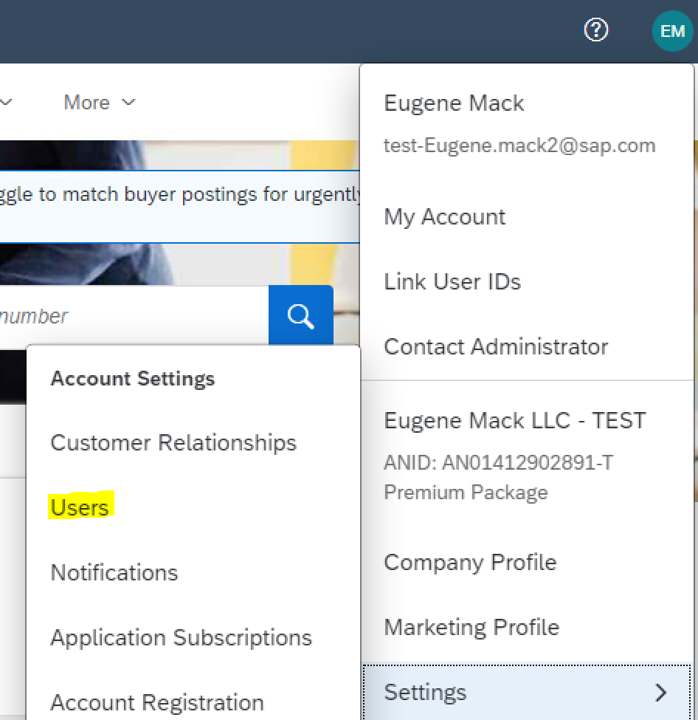

1. This will bring you to the “Manage Roles” sub tab. This step is required before creating users (which you will assign specific roles to based on their job responsibilities within the account) Click on the the + symbol in right hand side of the screen. Throughout the role creation process you will create 3 separate roles (Forecast Collaboration, PO Collaboration, Invoicing:

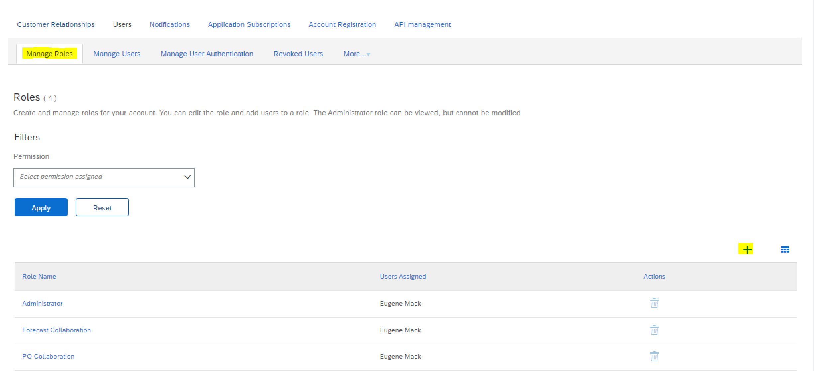

1. Create a name for the role and select the below permissions as depicted below for each role (As a note after creating one role you will need to save and repeat step 4 to create additional roles:

PO Collaboration Role:

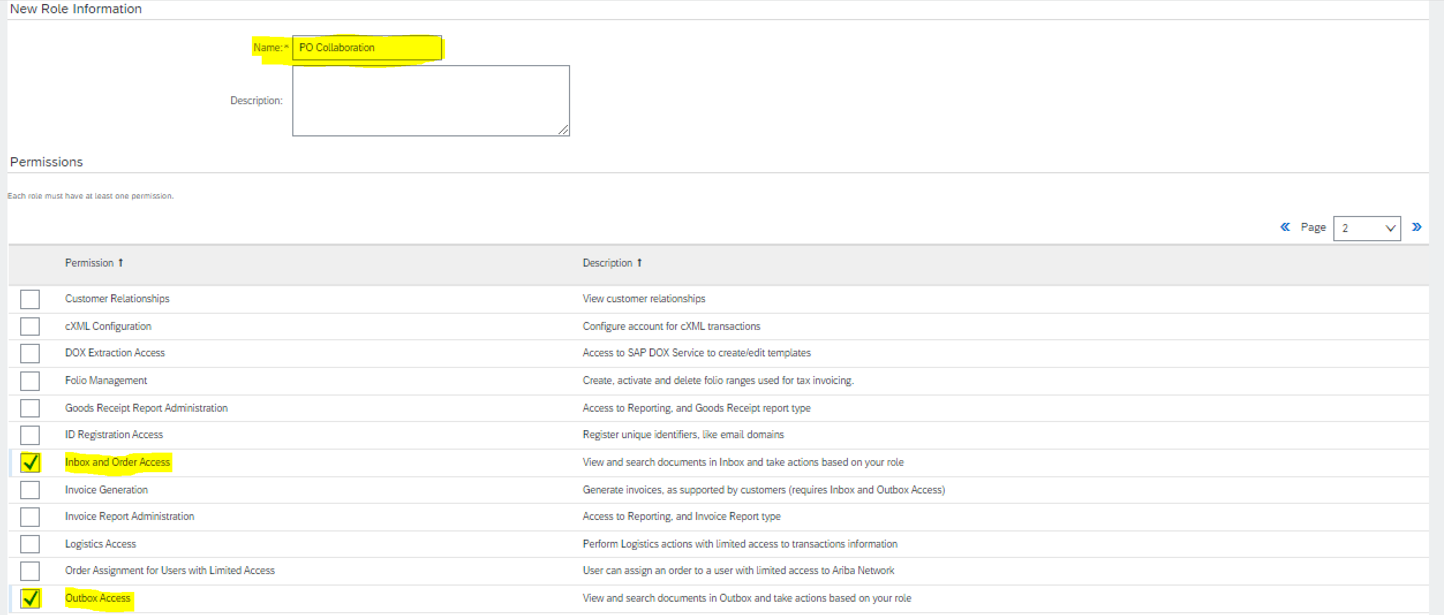

Forecast Collaboration Role:

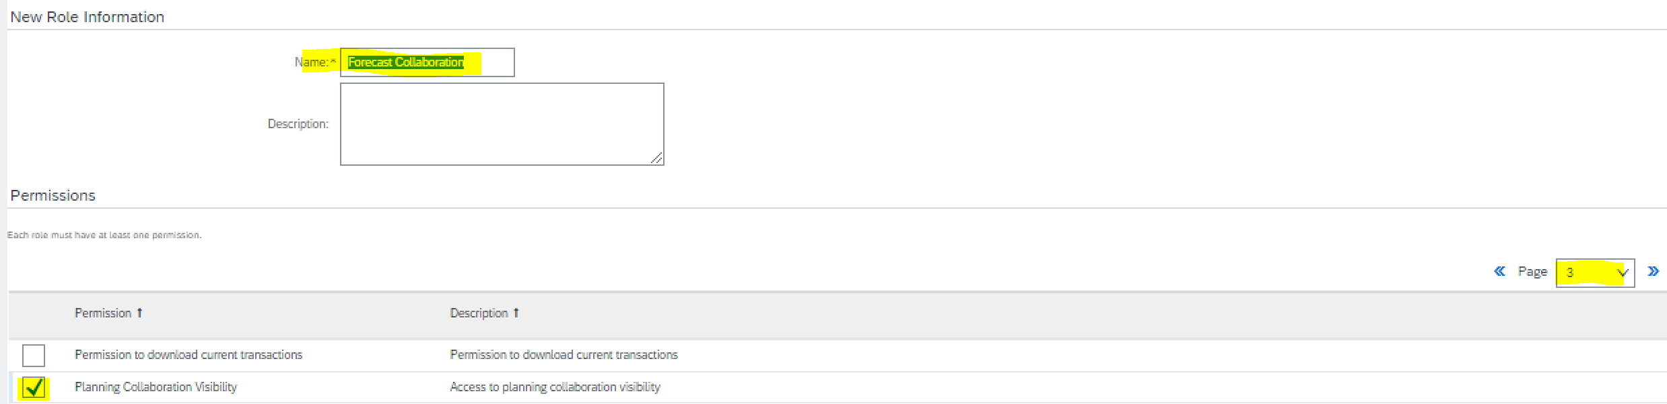

Invoice Collaboration Role:

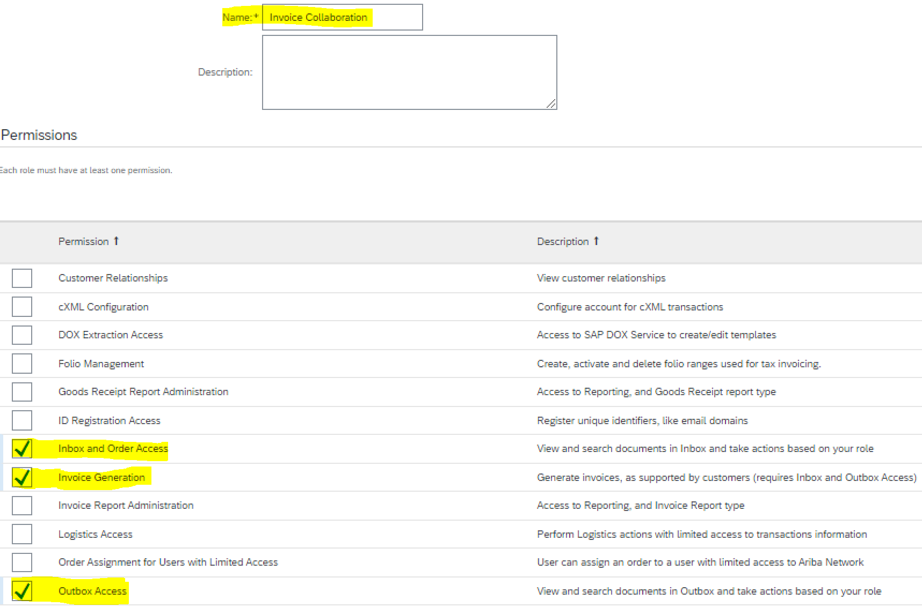

1. Click Save after creating each role
2. Click on Manage User sub tab:

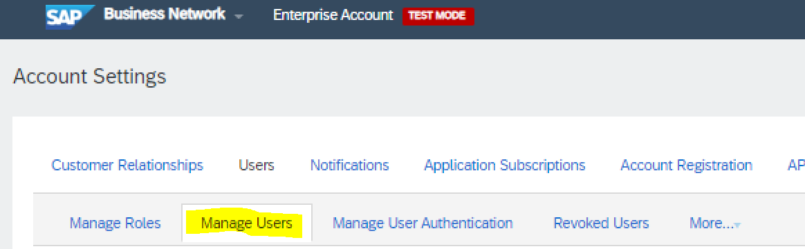

1. Click on + symbol in right hand corner of your screen:

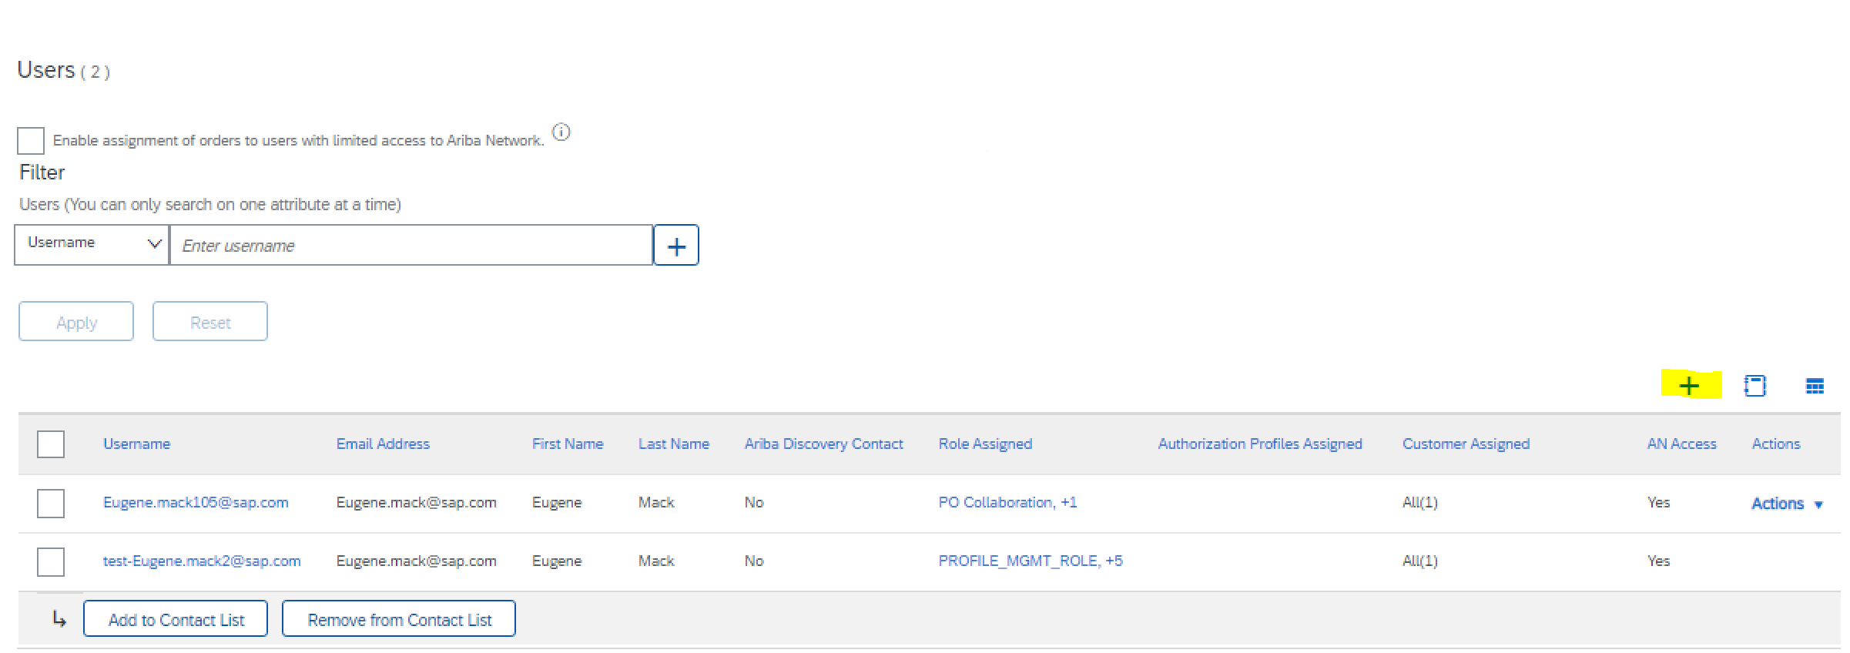

1. Insert all required information for user account and apply specific role assignment to user, highlighted in yellow below. As a note, when assigning the roles, you can assign multiple roles to one user :

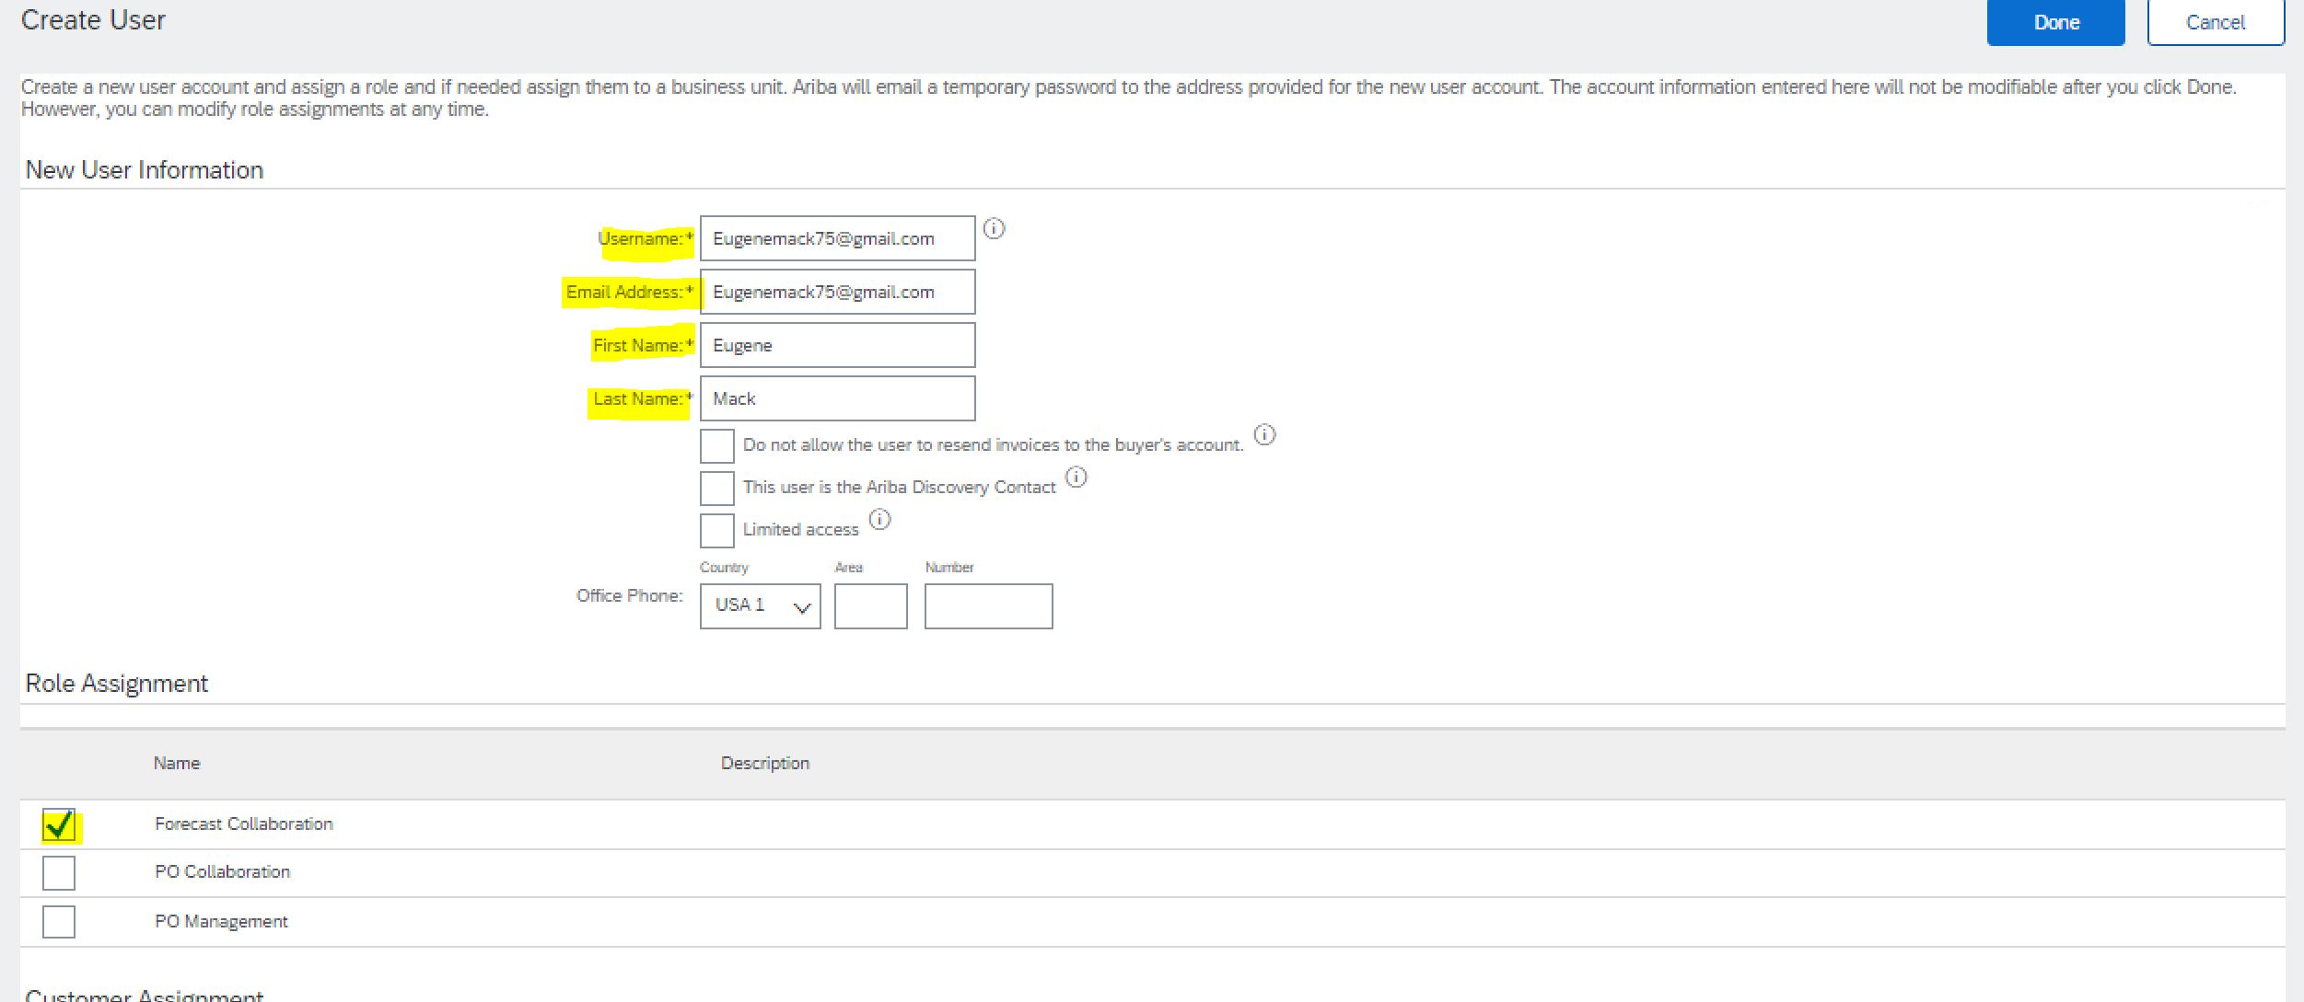

1. Click Done button, at bottom of screen:

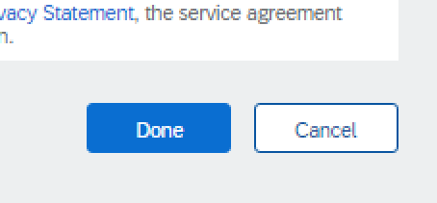

1. Click Save on following screen. :

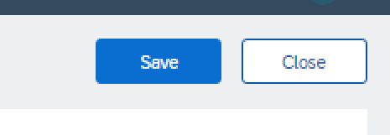

Once Save button is clicked, two emails will be sent to the email address of the user you created. The first email will contain a link to the supplier login page and the username of the user. The second email will contain a temporary password. The first time the new user logs in they will use the username and temporary password. It will then direct them to a screen to create their own password to use moving forward.