Creating Supplier Test Account

1. Login to your supplier account at supplier.ariba.com
2. Click initials in top right hand corner of homepage and click “switch to test account”:

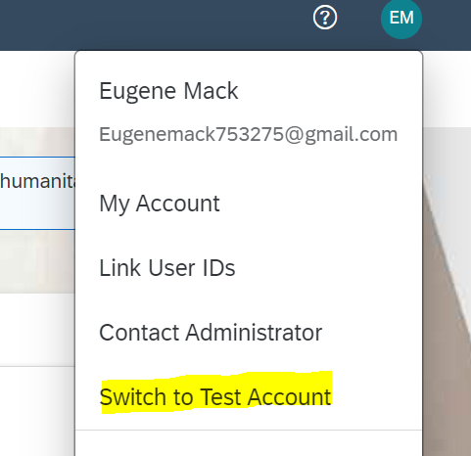

1. Click “Ok” button on next screen:

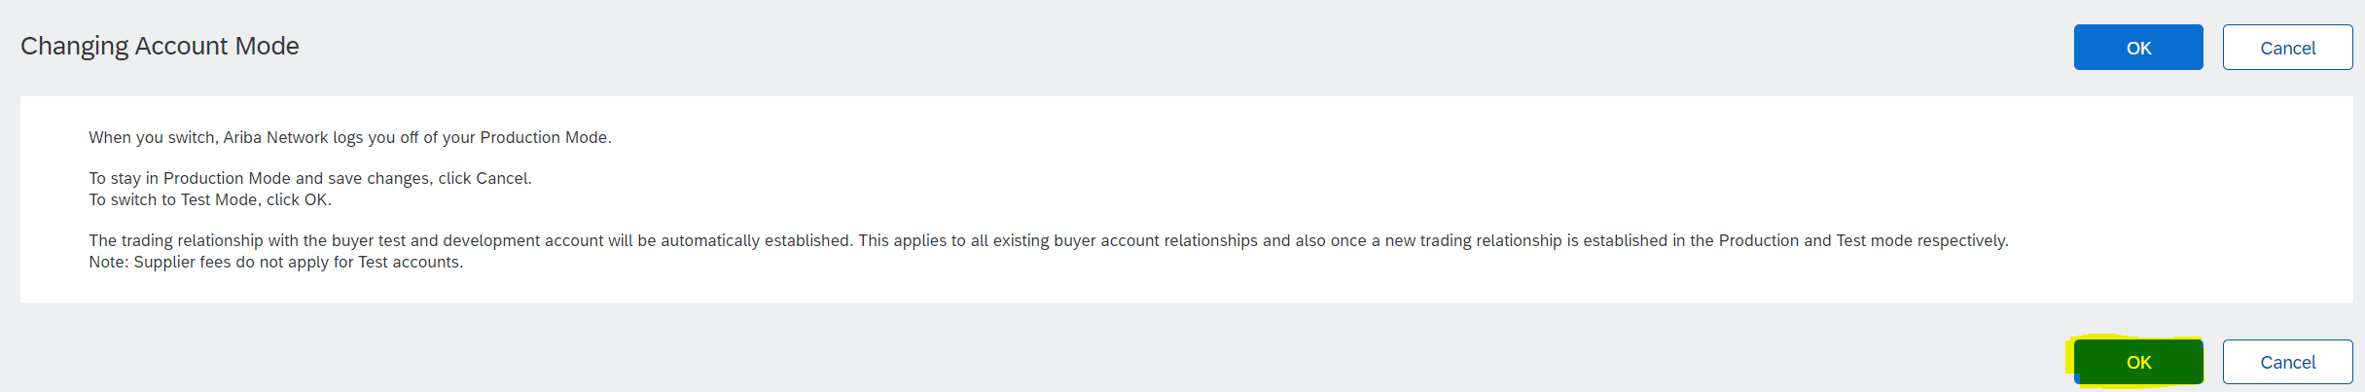

1. Insert password and repeat password. Then click “Ok” button:

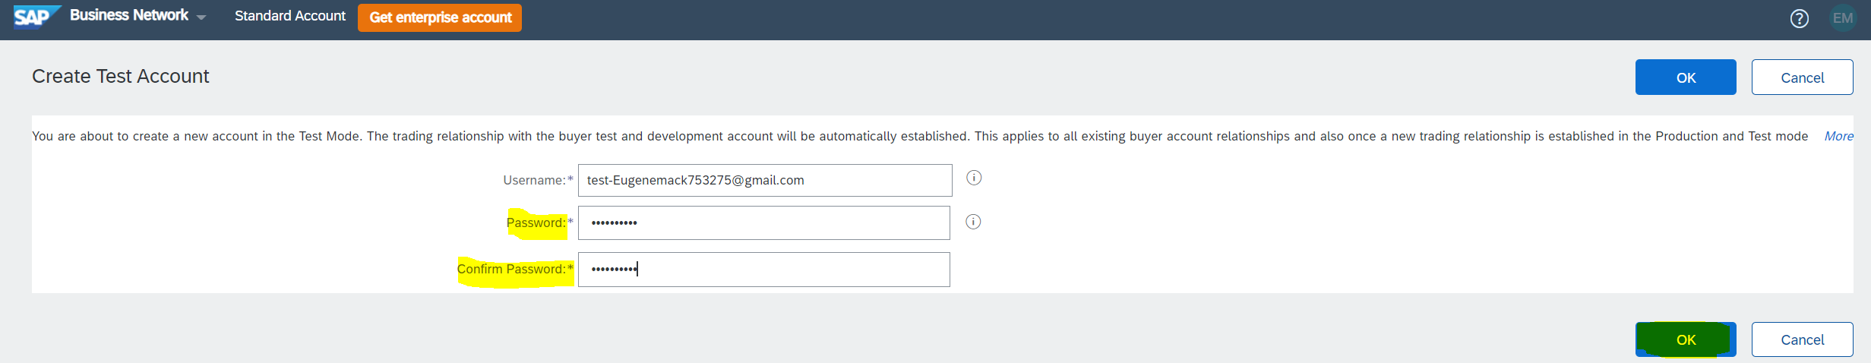

1. Select your primary business role from dropdown menu and click “Submit” button:

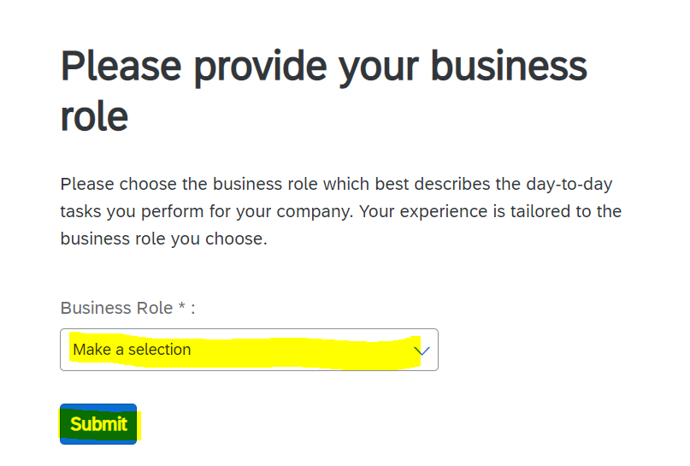

1. Select “Don’t show me this again” button:

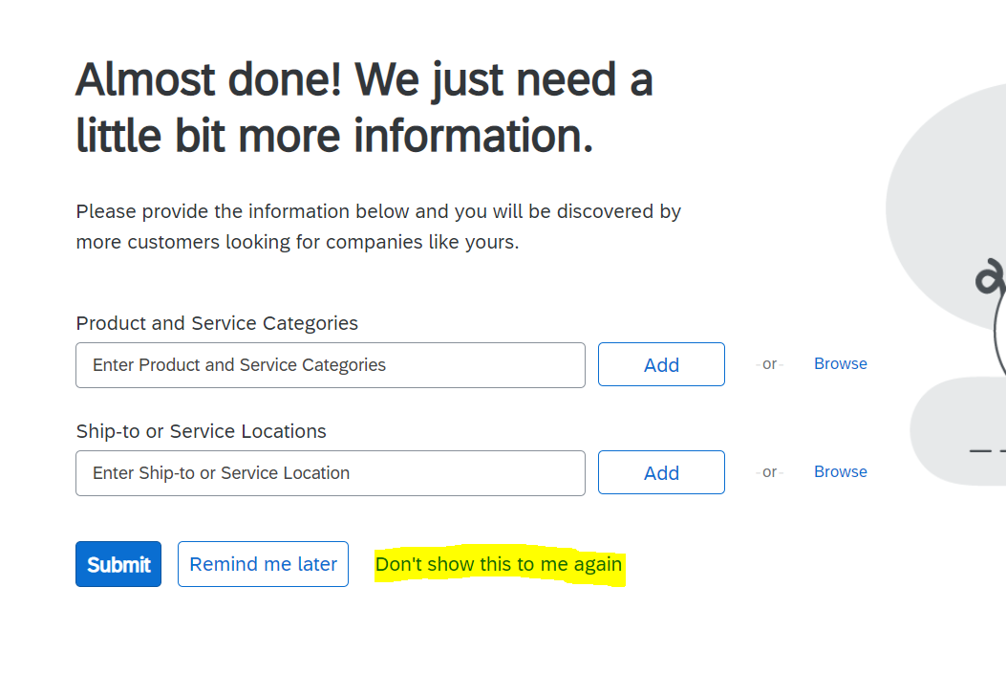

1. This will bring you into your homescreen of your newly created test account. As a note you will see at the top of your screen the “Test Mode” indicator and the account number will be the same as your production account number with a -T at the end:

