Configure Ship Notice Failure Notifications

1. Login to your supplier account at supplier.ariba.com
2. Click initials in top right hand corner of homepage and click settings:

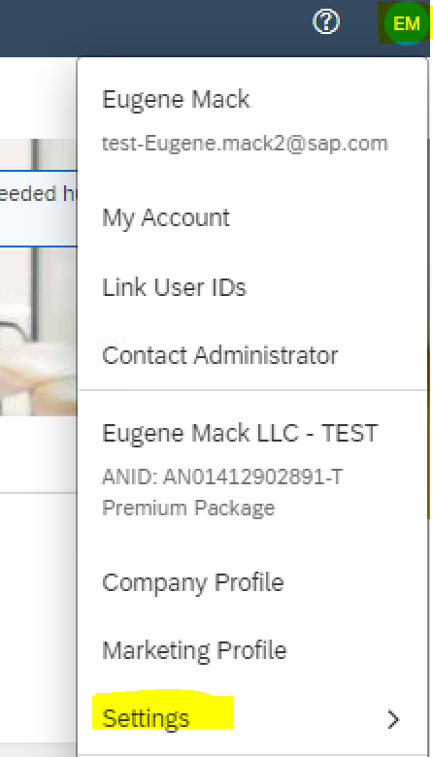

1. Select “Notifications”:

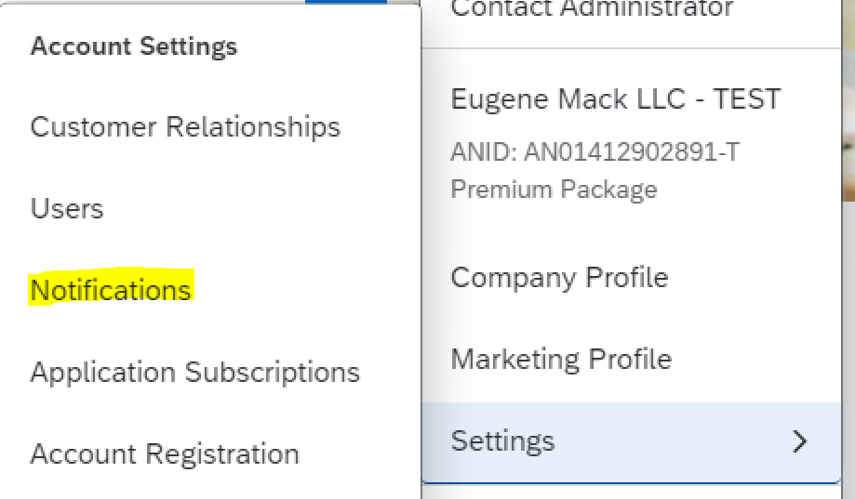

1. Click the Network sub tab:

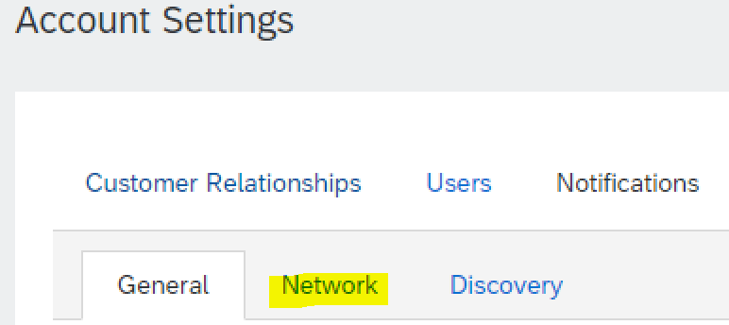

1. Click the check box for “Ship Notice Failure” and insert up to 3 email addresses to receive this notification. It should contain the email address of the resource at your organization who will be submitting Ship Notices:

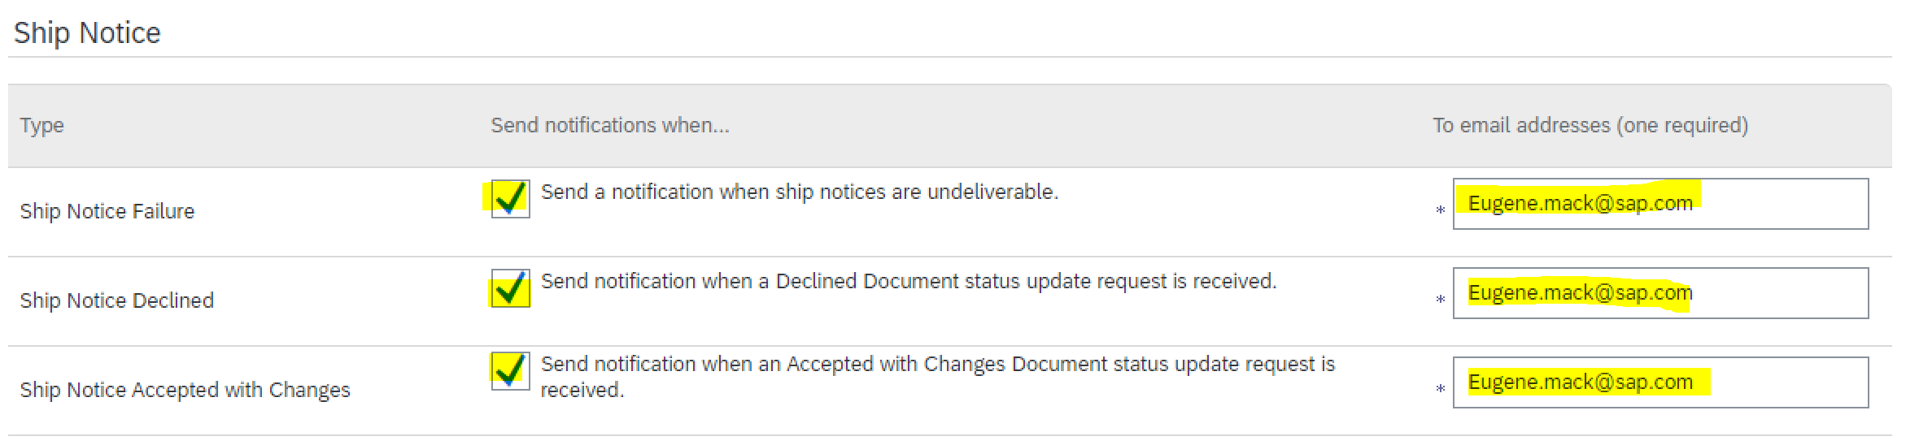

1. Click “Save” at the bottom of the screen:

