Accepting Stryker’s Trading Relationship Request

1. Click “Accept your customer’s trading relationship request within email sent to you from the email address [ordersend-prod@ansmtp.ariba.com](mailto:ordersend-prod@ansmtp.ariba.com)

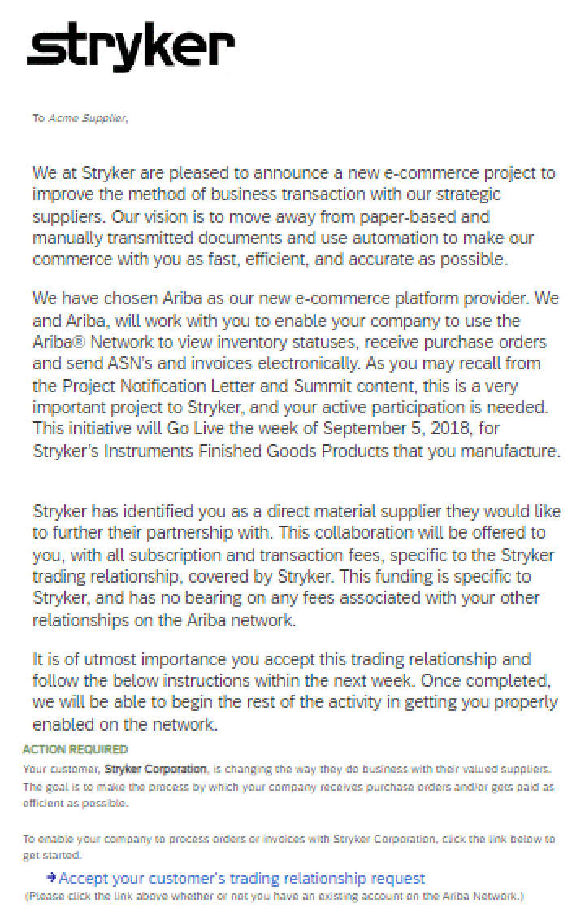

1. If you have an existing Ariba Network Supplier Enterprise account, select the option “use existing account. To create a brand new Ariba Network Supplier Enterprise Account, select “Create New Account”
2. Fill in all required company address information:

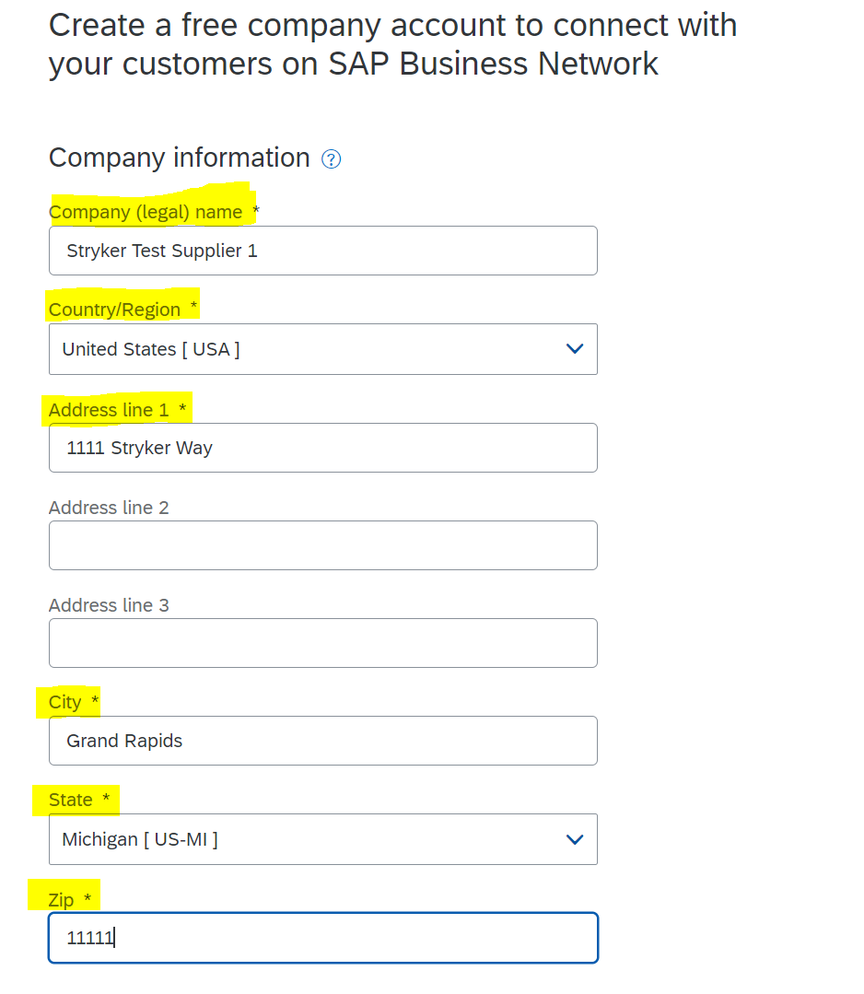

1. Create User Administrator Login Credentials by filling in required fields below (highlighted in yellow). As a note, please pay attention when creating your password it must contain all the criteria listed below in green font:

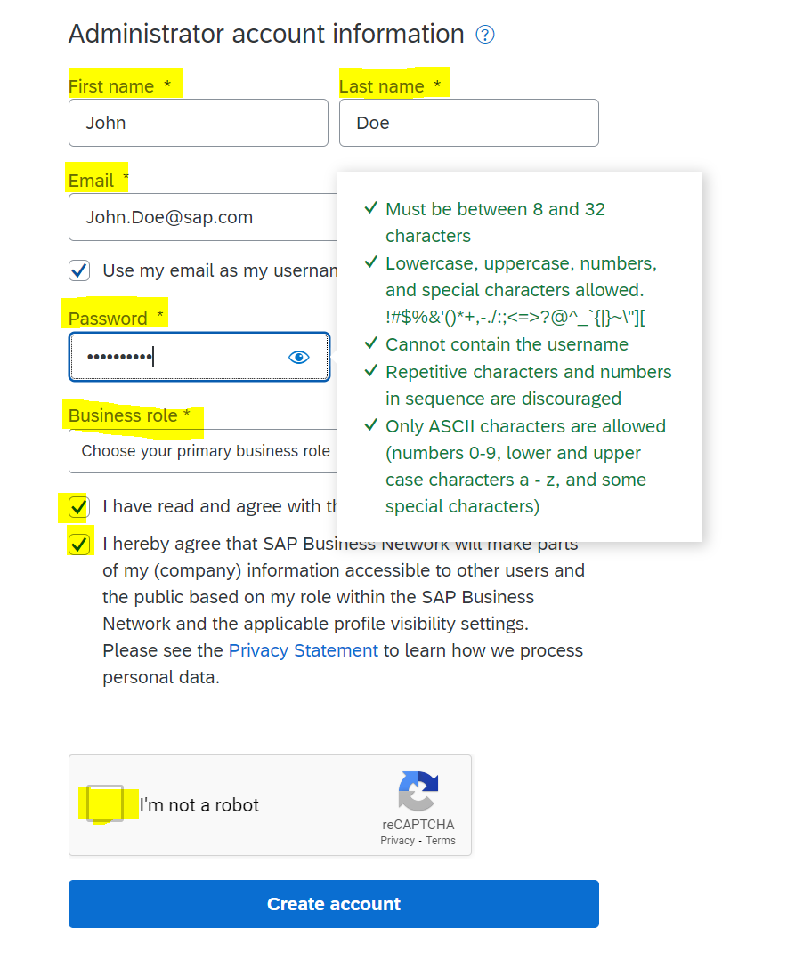

1. Click “Create Account”. This will then direct you to the home page of your newly created Ariba Network Supplier account.